Formulareinstellungen:

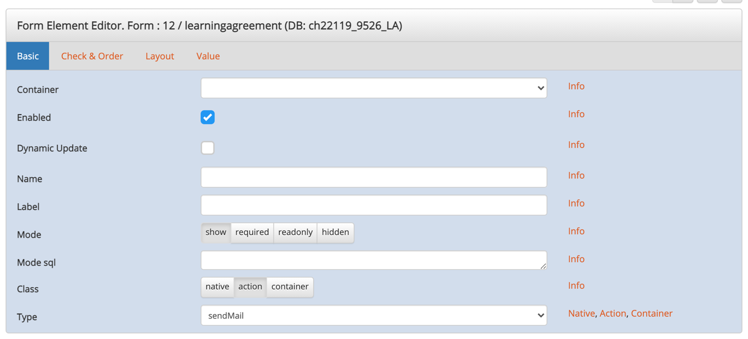

Value

{{SELECT IF( '{{masterprogram_id:FR:alnumx}}'='18' ,'Dear {{first_name:FE:allbut}} {{last_name:FE:allbut}}

Please print out the PDF and obtain the approvals and signatures of your thesis supervisor and of the Head of the Academic Support Office Biomedicine.
PDF link: http://www.learningagreement.ch/master/learningagreement.php?key1={{auth:R0}}

The signed learning agreement must be handed in to the Academic Support Office Biomedicine Irchel Campus 23 L08 at the beginning of the Master program.

Kind regards,

Academic Support Office Biomedicine
University of Zurich
Winterthurerstrasse 190
8057 Zurich
E-mail: master.biomedizin@physiol.uzh.ch', 'Dear {{first_name:FE:allbut}} {{last_name:FE:allbut}}

Please print out the PDF and obtain the approvals and signatures of your thesis supervisor and the coordinator of your Master program.
PDF link: http://www.learningagreement.ch/master/learningagreement.php?key1={{auth:R0}}

Bring the signed paper copy personally to the Academic Support Office (Studienkoordination, Y13-J-01, make an appointment by email).

Kind regards,

Academic Support Office Biology
University of Zurich
Winterthurerstrasse 190
8057 Zurich
E-mail: studienkoordination.biologie@uzh.ch' ) }}

Parameter

sendMailTo = {{email:F:allbut}}
sendMailCc = {{SELECT IF( '{{masterprogram_id:FR:alnumx}}'='18' ,'karin.niffeler@biol.uzh.ch', ' Karin.niffeler@biol.uzh.ch' ) }}
sendMailFrom = {{SELECT IF( '{{masterprogram_id:FR:alnumx}}'='18' ,'karin.niffeler@biol.uzh.ch', ' karin.niffeler@biol.uzh.ch' ) }}
sendMailSubject = Master of Science - Learning Agreement: {{first_name:F:allbut}} {{last_name:F:allbut}}

